

oneM2M
Technical Report
Document Number | oneM2M-TR-0041-V-0.4.0
Document Name: | oneM2M Decentralized Authentication
Date: | <2018-03-16>
Abstract: | Technical Report of oneM2M Decentralized Authentication
Template Version: January 2017 (Do not modify)

The present document is provided for future development work within oneM2M only. The Partners accept no liability for any use of this report.
The present document has not been subject to any approval process by the oneM2M Partners Type 1. Published oneM2M specifications and reports for implementation should be obtained via the oneM2M Partners' Publications Offices.

About oneM2M
The purpose and goal of oneM2M is to develop technical specifications which address the need for a common M2M Service Layer that can be readily embedded within various hardware and software, and relied upon to connect the myriad of devices in the field with M2M application servers worldwide.
More information about oneM2M may be found at: http//www.oneM2M.org
Copyright Notification
© 2017, oneM2M Partners Type 1 (ARIB, ATIS, CCSA, ETSI, TIA, TSDSI, TTA, TTC).
All rights reserved.
The copyright and the foregoing restriction extend to reproduction in all media.

Notice of Disclaimer & Limitation of Liability
The information provided in this document is directed solely to professionals who have the appropriate degree of experience to understand and interpret its contents in accordance with generally accepted engineering or other professional standards and applicable regulations. No recommendation as to products or vendors is made or should be implied.
NO REPRESENTATION OR WARRANTY IS MADE THAT THE INFORMATION IS TECHNICALLY ACCURATE OR SUFFICIENT OR CONFORMS TO ANY STATUTE, GOVERNMENTAL RULE OR REGULATION, AND FURTHER, NO REPRESENTATION OR WARRANTY IS MADE OF MERCHANTABILITY OR FITNESS FOR ANY PARTICULAR PURPOSE OR AGAINST INFRINGEMENT OF INTELLECTUAL PROPERTY RIGHTS. NO oneM2M PARTNER TYPE 1 SHALL BE LIABLE, BEYOND THE AMOUNT OF ANY SUM RECEIVED IN PAYMENT BY THAT PARTNER FOR THIS DOCUMENT, WITH RESPECT TO ANY CLAIM, AND IN NO EVENT SHALL oneM2M BE LIABLE FOR LOST PROFITS OR OTHER INCIDENTAL OR CONSEQUENTIAL DAMAGES. oneM2M EXPRESSLY ADVISES ANY AND ALL USE OF OR RELIANCE UPON THIS INFORMATION PROVIDED IN THIS DOCUMENT IS AT THE RISK OF THE USER.

Contents
Contents 3
1 Scope 4
2 References 4
2.1 Normative references 4
2.2 Informative references 4
3 Definitions, symbols and abbreviations 5
3.1 Definitions 5
3.2 Symbols 5
3.3 Abbreviations 5
4 Conventions, 6
5 Overview on Authentication and Decentralized Authentication Frameworks 6
5.1 Overview on Existing Authentication Frameworks 6
5.2 Overview on Decentralized Authentication 7
6 Issues and Requirements 7
6.1 Decentralized Authentication Requirement 7
6.2 IBC Credential Remote Provisioning Issue for Decentralized Authentication 8
7 Solutions 8
7.1 Decentralized Authentication for Peer-to-Peer Communications 8
7.1.1 Introduction 8
7.1.2 Detailed Solution 8
7.1.3 Algorithmic Details 10
7.1.4 Evaluation 11
7.2 Pre-Provisioned Symmetric Key Remote Security Provisioning Framework for Decentralized Authentication 11
7.2.1 Introduction 11
7.2.2 Detailed solution 11
7.2.3 Evalution 14
7.3 Certificate-Based Remote Security Provisioning Framework for Decentralized Authentication 14
7.3.1 Introduction 14
7.3.2 Detailed Solution 14
7.3.3 Evaluation 16
8 Conclusions 16
Proforma copyright release text block 16
Annexes 17
Annex <y>: Bibliography 17
History 18

1 Scope
The present document provides options and analyses for the security features and mechanisms providing decentralized authentication for oneM2M.
The Scope of this technical report includes high level architecture, generic requirements, available solutions and evalutions of these solutions for decentralized authentication.

2 References
The following text block applies.
References are either specific (identified by date of publication and/or edition number or version number) or non-specific. For specific references,only the cited version applies. For non-specific references, the latest version of the referenced document (including any amendments) applies.

2.1 Normative references
As a Technical Report (TR) is entirely informative it shall not list normative references.
The following referenced documents are necessary for the application of the present document.
[1] oneM2M TS-0003 Security Solutions.
[2] IETF RFC 4279: “Pre-Shared Key Ciphersuites for Transport Layer Security (TLS)”.
[3] IETF RFC 5705: “Keying Material Exporters for Transport Layer Security (TLS)”.
[4] IETF RFC 5408: “Identity-Based Encryption Architecture and Supporting Data Structures”.
[5] IETF RFC 5246: “The Transport Layer Security (TLS) Protocol Version 1.2”.
[6] IETF RFC 6347: “Datagram Transport Layer Security Version 1.2”.

2.2 Informative references
Clause 2.2 shall only contain informative references which are cited in the document itself.
The following referenced documents are not necessary for the application of the present document but they assist the user with regard to a particular subject area.
[i.1] Dan Boneh, Matthew K. Franklin: “Identity-Based Encryption from the Weil Pairing”, Proceedings of CRYPTO 2001.
[i.2] RFC 6507: “Elliptic Curve-Based Certificateless Signatures for Identity-Based Encryption (ECCSI)”, February, 2012.

3 Definitions, symbols and abbreviations
Delete from the above heading the word(s) which is/are not applicable.

3.1 Definitions
Clause numbering depends on applicability.
- A definition shall not take the form of, or contain, a requirement.
- The form of a definition shall be such that it can replace the term in context. Additional information shall be given only in the form of examples or notes (see below).
- The terms and definitions shall be presented in alphabetical order.
For the purposes of the present document, the [following] terms and definitions [given in ... and the following] apply:
Definition format
<defined term>: <definition>
If a definition is taken from an external source, use the format below where [N] identifies the external document which must be listed in Section 2 References.
<defined term>[N]: <definition>
example 1: text used to clarify abstract rules by applying them literally
NOTE: This may contain additional information.

3.2 Symbols
||: Concatenation
IdA: Identity of entity A
IdB: Identity of entity B
MPK: Master public key
MSK: Master secret key
SkA: Private key of entity A
SkB: Private key of entity B

3.3 Abbreviations
DH: Diffie-Hellman
DTLS: Datagram Transport Layer Security
IBC: Identity Based Cryptography
PKG: Private Key Generator
PKI: Public Key Infrastructure
PSK: Pre-shared Key
RSPF: Remote Security Provisioning Framework
SAEF: Security Association Establishment Framework
TLS: Transport Layer Security

4 Conventions,
The key words “Shall”, ”Shall not”, “May”, ”Need not”, “Should”, ”Should not” in this document are to be interpreted as described in the oneM2M Drafting Rules [i.1]

5 Overview on Authentication and Decentralized Authentication Frameworks

5.1 Overview on Existing Authentication Frameworks
The Security Association Establishment Frameworks (SAEFs) stipulated in [1] specify a diversity of methods to establish security in M2M systems, i.e. provisioned symmetric key-based SAEF, certificate-based SAEF and MAF-based SAEF, respectively.
Figure 5-1 (taken from [1]) provides a summary of the three SAEFs, where Entity A, which may be an AE or CSE, always acts as the client of the security association, while Entity B, which shall be a CSE, always acts as the server of the security association. Each SAEF in general comprises four stages that are Credential Configuration, Identity Configuration, Association Configuration and Association Security Handshake.
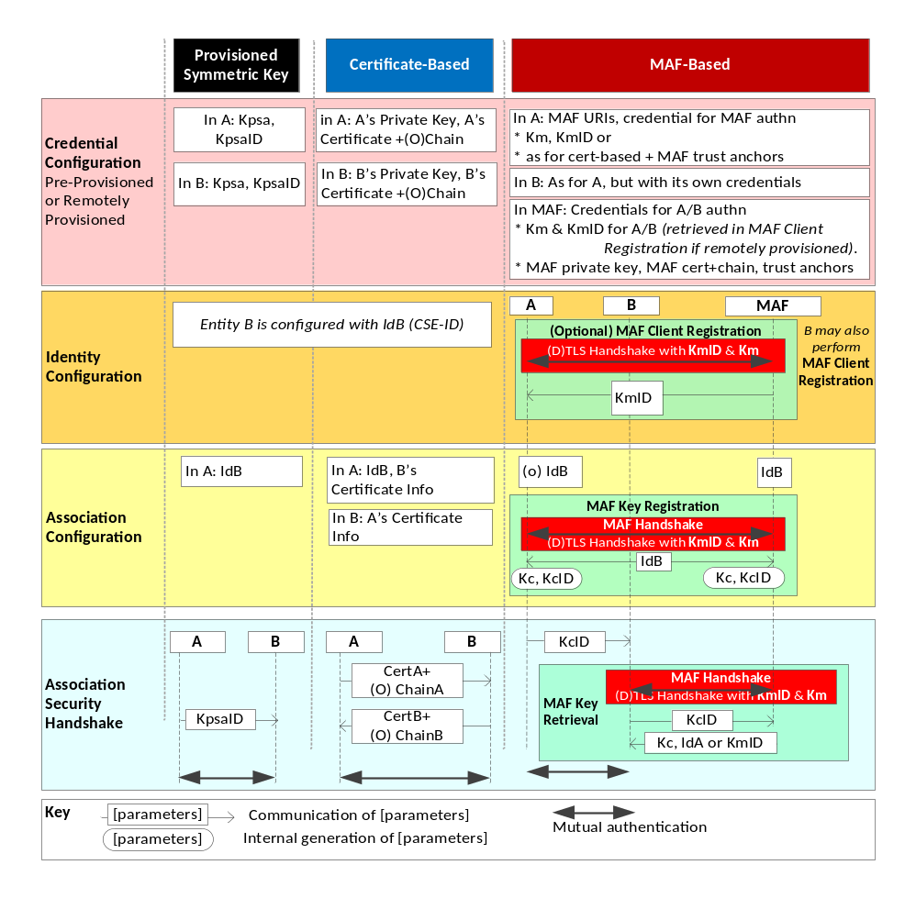
Figure 5-1: Overview of the Security Association Establishment Frameworks
supported by oneM2M
In particular, Credential Configuration is to provision entities with needed credentials that they can use to authenticate each other in Association Security Handshake. Credential provisioning can be through pre-provisioning, e.g., during device manufacturing or deployment, or through remote provisioning. Identity Configuration and Association Configuration shall configure entity A with the identity of entity B, directing entity A as the client of the security session to authenticate with entity B as the server. In Association Security Handshake, the secure sessions are established using (D)TLS handshakes.

5.2 Overview on Decentralized Authentication
The basic idea to realize decentralized authentication is to exploit the existing Security Association Establishment Frameworks (SAEFs) specified in [1], but with the entities using Identity-Based Cryptography (IBC) credentials.
Compared to the existing SAEFs, the credential of each entity is derived from an IBC mechanism. In the setting of IBC, there is a trusted third party, Private Key Generator (PKG), setting up the system parameters (MPK, MSK), where MPK is the master public key and MSK is the master secret key. An entity’s IBC credential comprises three elements, (Id, Sk, MPK), where Id is the entity’s identity, and Sk is the private key corresponding to the entity’s identity, and MPK is the master public key. Each entity’s private key Sk is generated by PKG from the entity’s identity Id, the master secret key MSK, as well as the master public key MPK.
In a nutshell, in comparison to the existing SAEFs, in Decentralized Authentication the Credential Configuration and the Association Security Handshake differ in certain ways, while the Identity Configuration and the Association Configuration remain the same.
Specifically, in the Association Security Handshake, once an IBC credential is provisioned to each of entity A and entity B, the two entities can derive a shared secret from their respective private keys Sk and their respective peers’ identities together with the IBC MPK. As a result, entities A and B are enabled to follow the existing Association Security Handshake to perform a (D)TLS PSK handshake with the computed shared secret acting as the pre-shared key. The details can be found in Clause 7.1. The advantage of using IBC in Decentralized Authentication is that for each pair of entity A and B, they can dynamically compute a shared secret between them, without pre-sharing a secret key PSK; this offers much flexibility in terms of key distribution, compared to the existing (D)TLS PSK handshake.
In the Credential Configuration, it would specify how to provision an IBC credential to each entity. The basic idea is to transfer the IBC credential from the MEF (M2M Enrolment Function) to the Enrolee through a secure channel established by either of the Remote Security Provisioning Framework (RSPF) mechanisms specified in Clause 8.3 of [1]. More specifically, once an IBC credential is generated by the PKG, the provision frameworks specified in Clause 7.2 and 7.3 would enable the Enrolee to obtain its IBC credential through a secure (D)TLS channel established by means of either Pre-Provisioned Symmetric Key or Certificate-Based RSPF, with the assumption that either the PKG is physically co-located with the MEF or the IBC credential for the Enrolee has been securely transmitted to the MEF. Besides, it goes without saying that the IBC credentials may also be pre-provisioned to the Enrolees rather than by remote provisioning, depending on applications.

6 Issues and Requirements

6.1 Decentralized Authentication Requirement
Clause 6.5 of TR-0026, Vehicular Domain Enabler, is “Use Cases for Electronic Toll Collection (ETC) service”. Two security requirements are set out in 6.5.10 of TR-0026 as follows:
…
- The M2M System shall enable each of many M2M devices to perform mutual authentication with each of many M2M gateways.
- The M2M System shall enable mutual authentication of M2M devices and M2M gateways in a timely manner.
Fulfilling these two requirements demands an efficient and flexible decentralized authentication solution for peer-to-peer communications.

6.2 IBC Credential Remote Provisioning Issue for Decentralized Authentication
Decentralized authentication is used to enable each entity to perform mutual authentication with many other entities in a timely manner, where all of these entities only have one credential.
Certificate-based mutual authentication and IBC (identity-based cryptography) based mutual authentication can both be used to realize decentralized authentication. Certificate-based mutual authentication may not be suitable for some IoT scenarios (e.g., V2V in smart vehicle), as the communication overhead compared to the message needed to be transmitted is high. So, IBC-based mutual authentication can be used in such scenarios.
In order to perform decentralized authentication using IBC based mutual authentication techniques, IBC credentials need to be provisioned to entities. Thus, the M2M System needs to provide mechanisms for remote provisioning of IBC credentials to entities that require IBC based mutual authentication.

7 Solutions

7.1 Decentralized Authentication for Peer-to-Peer Communications

7.1.1 Introduction
This clause presents a decentralized authentication framework for peer-to-peer communications. The framework enables mutual authentication between two entities (AE or CSE), each of which is provisioned an identity based cryptography (IBC) credential. The provisioning of an IBC credential could be pre-provisioing or remote provisioning. IBC distinguishes itself from conventional public key cryptography such as PKI with two features: (1) IBC avoids the use of certificates, while certificates management in PKI is extremely complex in practice; (2) IBC is expected to have better performance in some cases. These two features make the proposed decentralized authentication framework promising in addressing the issues in the above Clause 6.

7.1.2 Detailed Solution
In this framework, an IBC credential is provisioned to each entity, and two entities authenticate each other using (D)TLS handshake with PSK ciphersuite.
Figure 7.1.2-1 shows the sequence of events in this decentralized authentication framework using IBC credentials, wherein “Entity A” and “Entity B” could be either a CSE or an AE.
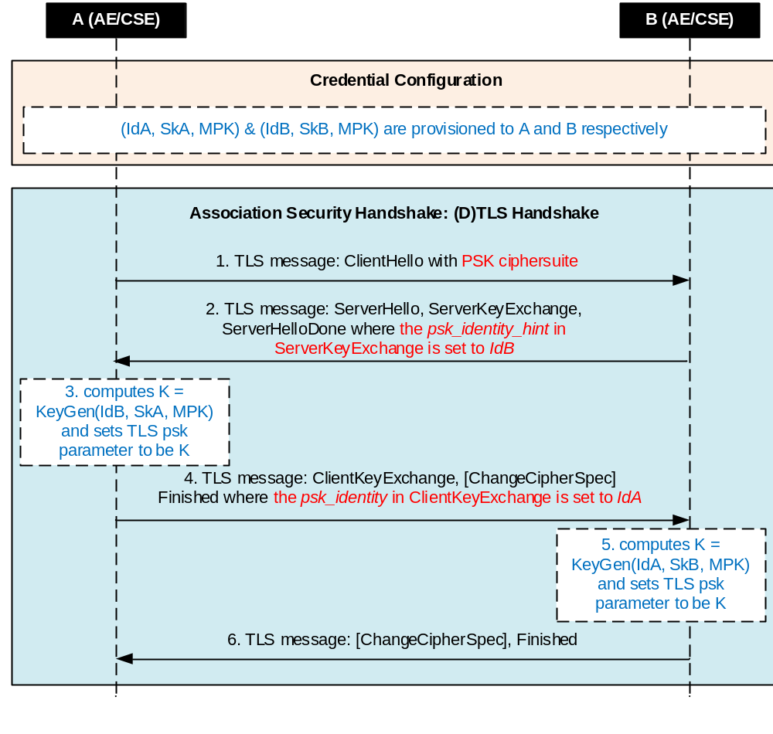
Figure 7.1.2-1: The sequence of events in decentralized authentication using IBC credentials
Credential Configuration: IBC credentials (IdA, SkA, MPK) and (IdB, SkB, MPK) are provisioned to entity A and entity B respectively, where IdA and IdB are the identities of entity A and entity B respectively, SkA and SkB are the private keys corresponding to IdA and IdB respectively, and the MPK is the master public key which is a public system parameter. Details of IBC credentials and their use in (D(TLS)-PSK handshake will be given in Clause 7.1.3.
Association Security Handshake: The entities shall perform a (D)TLS PSK handshake with IBC credentials to establish a secure session. The details are described as follows, where unless specified, TLS messages remain the same as in the original (D)TLS PSK handshake.
- Entity A initiates TLS with B using a TLS PSK ciphersuite, i.e., Entity A sends a TLS ClientHello message with PSK ciphersuite to entity B.
- Entity B returns TLS message ServerKeyExchange, in which the psk_identity_hint in ServerKeyExchange is set to IdB.
- After receiving ServerKeyExchange message, entity A retrieves IdB, computes a key K = KeyGen(IdB, SkA, MPK) and sets TLS psk parameter to be K, which will be used to authenticate entity B. Here, the function KeyGen can be implemented using different techniques, and two particular implementations are described shortly.
- Entity A sends TLS message ClientKeyExchange and Finished, where the psk_identity in ClientKeyExchange is set to IdA;
- After receiving ClientKeyExchange, entity B retrieves IdA, computes a Key K = KeyGen(IdA, SkB, MPK), and sets TLS psk parameter to be K, which will be used to authenticate entity A. Here, the function KeyGen can be implemented using different techniques, and two particular implementations are described shortly.
- Entity B sends TLS message Finished to A and completes the TLS PSK handshake.

7.1.3 Algorithmic Details
The IBC credential and the KeyGen algorithm based on the Elliptic Curve-Based Certificateless Signatures specified in [i.2] is provided.
7.1.3.1 Master Public Key
PKG, equivalent to KMS (Key Management Service) in [i.2], is responsible for establishing MPK and MSK in a setup phase. MPK includes the Static Parameters and the Community Parameters defined in Clause 4 of [i.2]. For the purpose of exposition, the relevant Static Parameters in [i.2] are listed in the following table.
Table 7.1.3.1-1 Static Parameters
N | A security parameter; the size in bits of the prime p over which elliptic curve cryptography is to be performed.
P | A prime number of size n bits. The finite field with p elements is denoted F_p
E | An elliptic curve defined over F_p, having a subgroup of prime order q
B | An element of F_p, where E is defined by the formula y^2 = x^3 - 3*x + B modulo p
G | A point on the elliptic curve E that generates the subgroup of order q
Q | The prime q is defined to be the order of G in E over F_p
hash | A cryptographic hash function mapping arbitrary strings to strings of N octets, where N = Ceiling(n/8) is the number of  octets output by the hash function

The Community Parameters in [i.2] are KPAK, which is the KMS Public Authentication Key. KPAK is derived from the KSAK (KMS Secret Authentication Key) in KMS as KPAK = [KSAK]G, where the KSAK is chosen to be a random secret non-zero integer modulo q and is kept secret to the KMS. The MSK is KSAK.

As a result, MPK = (n, p, E, B, G, q, Hash, KPAK) and MSK = (KSAK).

7.1.3.2 IBC Credential
In Clause 5.1 [1.2], user key material is defined as a (SSK, PVT) pair, where SSK is Secret Signing Key and PVT is Public Validation Token. The SSK is kept secret, but the PVT does not need to be kept secret. The algorithm to generate (SSK, PVT) pair is defined in Clause 5.1.1 of [i.2] and specified as follows.

Let ID_{U} be the identifier of an entity U. A (SSK_{U}, PVT_{U}) pair is constructed from ID_{A} by KMS through the following procedures:
- Choose v_{U}, a random (ephemeral) non-zero element of F_q;
- Compute PVT_{U} = [v_{U}]G;
- Compute a hash value HS_{U} = hash(G || KPAK || ID_{U}|| PVT_{U}), an N-octet integer;
- Compute SSK_{U} = (KSAK + HS_{U} * v_{U}) modulo q;
- If either the SSK_{U} or HS_{U} is zero modulo q, the KMS erases the SSK_{U} and aborts or restart the procedure with a fresh value of v_{U};
- Output the (SSK_{U}, PVT_{U}) pair. The KMS then erases the value v.

Given (SSK_{U}, PVT_{U}) for entity U, the IBC credential (IdU, SkU, MPK) for entity U is specified to be IdU = (ID_{U}, PVT_{U}) and SkU = SSK_{U}.

7.1.3.2 KeyGen Algorithm
Let entity A and entity B in Figure 7.1.2-1 have IBC credentials (IdA = (ID_{A},PVT_{A}), SkA = SSK_{A}, MPK) and (IdB = (ID_{B},PVT_{B}), SkB = SSK_{B}, MPK), respectively, where PVT_{A} = [v_{A}]G, SSK_{A} = KSAK + HS_{A}*v_{A} modulo q, PVT_{B} = [v_{B}]G, SSK_{B} = KSAK + HS_{B}*v_{B} modulo q, with v_{A} and v_{B} being two random non-zero element of F_q, HS_{A} = hash(G||KPAK||ID_{A}||PVT_{A}) and HS_{B} = hash(G||KPAK||ID_{B}||PVT_{B}). The key generation function is defined as follows.

KeyGen for A
Input: IdB = (ID_{B}, PVT_{B}), SkA = (KSAK + HS_{A}*v_{A}) modulo q, MPK
Output: K_{A} – an elliptic curve point
- Parse IdB into ID_{B} and PVT_{B};
- Compute HS_{B} = hash(G||KPAK||ID_{B}||PVT_{B});
- Compute TMP = KPAK + [HS_{B}]PVT_{B};
- Compute K_{A} = [SSK_{A}]TMP;
- Output K_{A}.

KeyGen for B
Input: IdA = (ID_{A},PVT_{A}), SkB = (KSAK + HS_{B}*v_{B}) modulo q, MPK
Output: K_{B} – an elliptic curve point
- Parse IdA into ID_{A} and PVT_{A};
- Compute HS_{A} = hash(G||KPAK||ID_{A}||PVT_{A});
- Compute TMP = KPAK + [HS_{A}]PVT_{A};
- Compute K_{B} = [SSK_{B}]TMP;
- Output K_{B}.

Note: It is obvious that K_{A} = K_{B}, as K_{A} = [SSK_{A}]TMP = [SSK_{A}](KPAK + [HS_{B}]PVT_{B}) = [(KSAK + HS_{A}*v_{A}][ KSAK + HS_{B}*v_{B}]G and K_{B} = [SSK_{B}]TMP = [SSK_{B}](KPAK + [HS_{A}]PVT_{A}) = [(KSAK + HS_{B}*v_{B}][ KSAK + HS_{A}*v_{A}]G;

7.1.4 Evaluation
The proposed TLS PSK handshake has a variation compared to the original TLS PSK: the two entities are assumed to be provisioned a pre-shared key in the latter, while in the former the two entities generate the shared key on the fly based on their respective provisioned private keys, rather than pre-sharing it. This variation in fact offers enormous flexibility in the proposed framework: with a single provisioned credential, an entity can communication with (authenticate or be authenticated to) any entity who also has a valid single credential; in contrast, in the original TLS PSK handshake, an entity has to be provisioned a credential (i.e., pre-shared key) for each of the entities it wants to communicate with. This flexibility is on top of the features associated with IBC mentioned earlier.
Besides, the authentication steps follow exactly the original TLS PSK handshake, thus security of the mutual authentication process is guaranteed, unless the on-the-fly generation of shared key is not secure. The first instantiation of the IBC credentials and the KeyGen algorithm has been well studied in the literature; the second instantiation of the KeyGen algorithm is essentially a static DH (Diffie-Hellman) key exchange based on the two entities’ IBC credentials, which has been widely accepted as well. As a result, security of the proposed mutual authentication process is established.

7.2 Pre-Provisioned Symmetric Key Remote Security Provisioning Framework for Decentralized Authentication

7.2.1 Introduction
In this Clause, Pre-Provisioned Symmetric Key based RSPFs are used to provision identity-based cryptography (IBC) credential to an Enrolee for decentralized authentication. This clause is intended to solve the issue identified in Clause 6.2.
IBC credentials include three elements, denoted by (Id, Sk, MPK), where Id and Sk are the identity and the corresponding private key of an Enrolee, MPK is the master public key which is a public system parameter.
IBC credentials may also be pre-provisioned; that is, provisioned using means other than a Remote Security Provisioning Framework. The method for pre-provisioning can be deployment dependent.

7.2.2 Detailed solution
This clause describes the Pre-Provisioned Symmetric Key based RSPF for Decentralized Authentication, which is adapted from Clause 8.3.2.1 of [1].
The Bootstrap Credential for this framework is a long-term symmetric key that has been pre-provisioned into the Enrolee and M2M Enrolment Function; this key is called a Pre-Provisioned Symmetric Enrolee Key and is denoted Kpm.
NOTE 1: Long term Pre-Provisioned Symmetric Enrolee Keys can pose a security risk if not adequately secured, and for this reason it is recommended that Long term Pre-Provisioned Symmetric Enrolee Keys are stored in Secure Environments.
Figure 7.2.2-1 illustrates the sequence of events when using the Pre-Provisioned Symmetric Enrolee Key Remote Security Provisioning Framework for Decentralized Authentication.
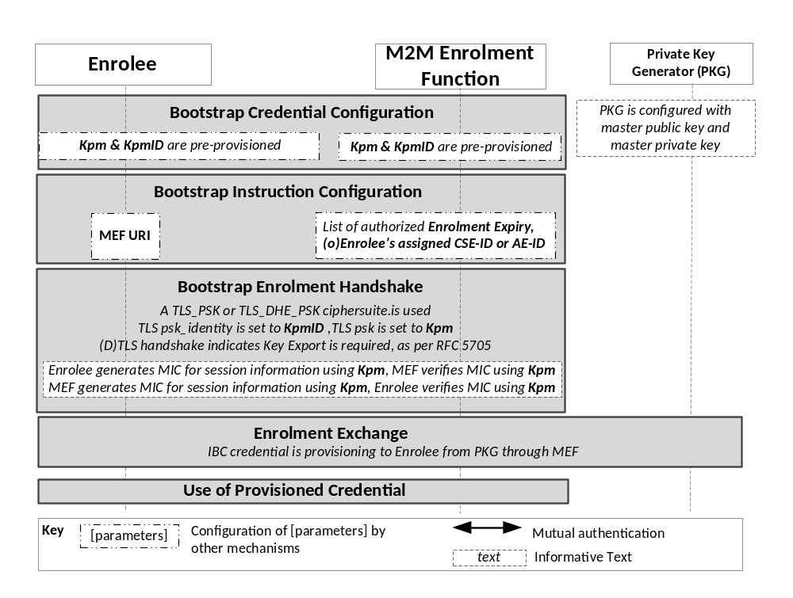
Figure 7.2.2-1: The sequence of events when using the Pre-Provisioned Symmetric Key Remote Security Provisioning Framework for Decentralized Authentication

Bootstrap Credential Configuration: The Pre-Provisioned Symmetric Enrolee Key (Kpm) and the corresponding Pre-Provisioned Symmetric Enrolee Key Identifier, denoted KpmID, are pre-provisioned to both entities.
NOTE 2: This pre-provisioning (by definition) uses mechanisms not specified by oneM2M.
Bootstrap Instruction Configuration: The Enrolee and M2M Enrolment Function are configured with the information needed for authorizing the remote provisioning:
- The Enrolee is configured with (or otherwise obtains) the following arguments to initiate remote provisioning:
- MEF URI: URI of M2M Enrolment Function for the purpose of routing the (D)TLS exchange.
- The Enrolee associates these arguments with the M2M Enrolment Function. The M2M Enrolment Function can be identified to the Enrolee using the Pre-Provisioned Symmetric Enrolee Key Identifier (KpmID) or the M2M Enrolment Function URI.
- M2M Enrolment Function is configured with the following arguments to authorize the M2M Enrolment Function to remotely provision the Enrolee for decentralized authentication:
- Enrolee's assigned CSE-ID or AE-ID (Enrolee-ID). The M2M Enrolment Function is to provide this entity identity for the Enrolee with the Km or Kpsa.
- Enrolment Expiry: Life Time to be applied for the IBC credential generated.
- The M2M Enrolment Function associates these arguments with an Enrolee. The Enrolee can be identified to the M2M Enrolment Function using the Pre-Provisioned Symmetric Enrolee Key Identifier (KpmID).
Bootstrap Security Handshake:
- The Enrolee and M2M Enrolment Function shall perform a (D)TLS-PSK handshake [2] to establish a secure session.
- The "psk_identity" parameter [2] is set to the value of the Pre-Provisioned Symmetric Enrolee Key Identifier (KpmID).
- The "psk" parameter [2] is set to the value of the Pre-Provisioned Symmetric Enrolee Key (Kpm).
- The (D)TLS cipher suite profile is specified in clause 10.2.2 of [1] "TLS and DTLS Ciphersuites for TLS-PSK-Based Security Frameworks".
Enrolment Key Generation:
- The Enrolment Key (Ke), RelativeKeID, and Enrolment Re-authentication Key (Ker) are generated from the (D)TLS session secrets by the Enrolee and M2M Enrolment Function using TLS Key Export (IETF RFC 5705 [3]), as described in clause 10.3.1 of [1] "TLS Key Export Details".
- The Enrolment Key Identifier (KeID) is generated from the RelativeKeID and the M2M Enrolment Function's FQDN by the Enrolee and M2M Enrolment Function, as described in clause 10.3.4 of [1] "Generating KeID".
- The Enrolee and M2M Enrolment Function store the Enrolment Key (Ke) and Enrolment Key Identifier (KeID), and Enrolment Re-Authentication Key (Ker).
NOTE 3: The Enrolment Key Generation for the Pre-Provisioned Symmetric Enrolee Key Remote Security Provisioning Framework is identical to the Enrolment Key Generation for the Certificate-Based Remote Security Provisioning Framework.
Enrolment Exchange:
- The Enrolee composes a request of notifying MEF to execute IBC credential enrolment and sends the request to the MEF’s Enrolment Exchange URI.
- The MEF process this request to determine how the Enrolee is to be provisioned.
- The MEF composes a response with an indication of IBC credential enrolment and sends it to the Enrolee.
- After receiving the response, the Enrolee performs IBC credential enrolment procedure as described below:
Note: Private Key Generator (PKG) provides key generation service for IBC credentials which is configured with master public key and master private key. A PKG accepts an entity’s identity and generates a corresponding IBC private key[3][4]. In oneM2M system, the PKG can be MEF or other server which provides a root of trust for all entities in oneM2M system.
Editor’s note: Impact of supporting PKG functionality on MEF interface has to be investigated.
Note: The Enrolee and the MEF have successfully established a TLS session and communication between the MEF and the PKG is protected by existing secure channel.
  - The Enrolee sends a request with its identity ID1 (CSE-ID or AE-ID) to the MEF;
  - The MEF generates a new identity ID2 for the enrolee based on the received identity and the expiry time for this IBC credential (e.g., adding FQDN and expired time before the received identity) to make sure the new identity is exclusive and forward the new identity to the Private Key Generator (PKG);
  - The PKG generates a private key Sk for the received identity ID2 based on the master public MPK and the master secret key MSK; and sends the Sk and MPK back to the MEF;
  - The MEF sends (ID2, Sk, MPK) to the Enrolee.
- The Enrolee stores the IBC credential (ID2, Sk, MPK) and sends a request to the MEF indicating success.
- The MEF sends a response indicating the end of the enrolment exchange.
- The MEF closes the TLS/DTLS session.
Use of Remotely Provisioned Credential:
If the Enrolee is remotely provisioned with an IBC credential, then the Enrolee can use the credential to preform decentralized authentication with other entities (CSE or AE) in oneM2M system.

7.2.3 Evalution
Pre-provisioned symmetric key based RSPF is similar to the pre-provisioned symmetric key based RSPF in clause 8.3.2.1 of [1]. The communications between the Enrolee and the MEF are transmitted through secure channels (e.g., built by (D)TLS) based on the pre-provisioned symmetric key, so the IBC credentials can be securely provisioned to the Enrolee.

7.3 Certificate-Based Remote Security Provisioning Framework for Decentralized Authentication

7.3.1 Introduction
In this clause, Certificate-Based RSPF is used to provision identity-based cryptography (IBC) credentials to an Enrolee for decentralized authentication.This is intended to solve the issue identified in Clause 6.2.

IBC credentials include three elements, denoted by (Id, Sk, MPK), where Id and Sk are the identity and the corresponding private key of an Enrolee, MPK is the master public key which is a public system parameter.
IBC credentials may also be pre-provisioned; that is, provisioned using means other than a Remote Security Provisioning Framework. The method for pre-provisioning can be deployment dependent.

7.3.2 Detailed Solution
This clause describes Certificate-Based Remote Security Provisioning Framework for Decentralized Authentication, which is adapted from Clause 8.3.2.2 of [1]. The Bootstrap Credential for this framework are certificates.
Figure 7.3.2-1 illustrates the sequence of events when using the Certificate-Based Remote Security Provisioning Framework for Decentralized Authentication.
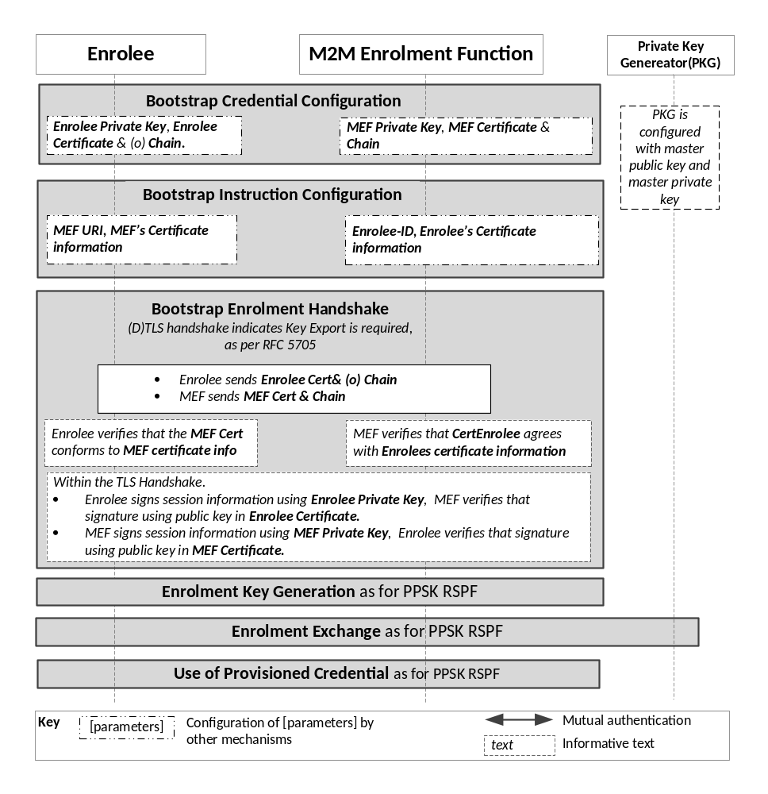
Figure 7.3.2-1: The sequence of events when using the Certificate-Based Remote Security Provisioning Framework for Decentralized Authentication

Bootstrap Credential Configuration: For this Remote Security Provisioning Framework, Enrolee and M2M Enrolment Function authenticate each other using a Public Key Certificate. The Bootstrap Credentials for the Enrolee and M2M Enrolment Function are pre-provisioned as described in clause 8.1.2.3 of [1] "Credential Configuration for Certificate-Based Security Frameworks".
NOTE 1: The identity of the M2M Enrolment Function is assumed to have been configured prior to this phase.
Bootstrap Instruction Configuration: The Enrolee and M2M Enrolment Function are configured with the information needed for authorizing the remote provisioning:
- The Enrolee is configured with (or otherwise obtains) the following arguments to initiate remote provisioning:
- MEF URI: URI of M2M Enrolment Function for the purpose of routing the (D)TLS exchange.
- Information needed for certificate authentication of the M2M Enrolment Function using an MEF certificate as described in clause 8.1.2.4 of [1] "Information Needed for Certificate Authentication of another Entity".
- M2M Enrolment Function is configured with the following arguments to authorize the M2M Enrolment Function to remotely provision the Enrolee for decentralized authentication:
- Enrolee's assigned CSE-ID or AE-ID (Enrolee-ID). The M2M Enrolment Function is to provide this entity identity for the Enrolee with the Km or Kpsa.
- Enrolment Expiry: Life Time to be applied for the IBC credential generated.
- Information needed for certificate authentication of the Enrolee, as described in clause 8.1.2.4 of [1] "Information Needed for Certificate Authentication of another Entity".
Bootstrap Security Handshake: The Enrolee and M2M Enrolment Function perform a (D)TLS handshake as specified in TLS 1.2 IETF RFC 5246 [5] and DTLS 1.2 IETF RFC 6347 [6] specifications to establish a secure session.
- Each entity (Enrolee and M2M Enrolment Function) verifies the other entity's certificate as described in clause 8.1.2.5 of [1] "Certificate Verification".
- The Enrolee and M2M Enrolment Function authenticate each other using the validated certificates as specified in TLS 1.2 IETF RFC 5246 [5] and DTLS 1.2 IETF RFC 6347 [6] specifications.
- The (D)TLS cipher suite profile is specified in clause 10.2.3 of [1] "TLS and DTLS Ciphersuites for Certificate-Based Security Frameworks".
Enrolment Key Generation, Enrolment Exchange and Use of Provisioned Credentials:
- The steps are identical to those shown for "Enrolment Key Generation", "Enrolment Exchange" and "Use of Provisioned Credentials" in "Pre-Provisioned Symmetric Key Remote Security Provisioning Framework for Decentralized Authentication".

7.3.3 Evaluation
Certificate-based RSPF is similar to the certificate-based RSPF in clause 8.3.2.1 of [1]. The communications between the Enrolee and the MEF are transmitted through secure channels (e.g., built by (D)TLS) based on the pre-provisioned certificates, so the IBC credentials can be securely provisioned to the Enrolee.

8 Conclusions
The present document offers an overview of the use cases, requirements and available solutions for IBC-based authentication for oneM2M.

The following text is to be used when appropriate:

Proforma copyright release text block
This text box shall immediately follow after the heading of an element (i.e. clause or annex) containing a proforma or template which is intended to be copied by the user. Such an element shall always start on a new page.
Notwithstanding the provisions of the copyright clause related to the text of the present document, oneM2M grants that users of the present document may freely reproduce the <proformatype> proforma in this {clause|annex} so that it can be used for its intended purposes and may further publish the completed <proformatype>.
<PAGE BREAK>

Annexes
Each annex shall start on a new page (insert a page break between annexes A and B, annexes B and C, etc.).
Use the Heading 9 style for the title and the Normal style for the text.
Annex <A>:
Title of annex (style H9)
<Text>
<PAGE BREAK>
Annex <B>:
Title of annex (style H9)
<Text>
B.1 First clause of the annex (style H1)
<Text>
B.1.1 First subdivided clause of the annex (style H2)
<Text>
<PAGE BREAK>

Annex <y>:
Bibliography
The annex entitled "Bibliography" is optional.
It shall contain a list of standards, books, articles, or other sources on a particular subject which are not mentioned in the document itself.
It shall not include references mentioned in the document.
Use the Heading 9 style for the title and B1+ or Normal for the text.
- <Publication>: "<Title>".
OR
<Publication>: "<Title>".
<PAGE BREAK>

History
This clause shall be the last one in the document and list the main phases (all additional information will be removed at the publication stage).
Publication history
V1.1.1 | <yyyy-mm-dd> | <Milestone>

Draft history (to be removed on publication)
V0.0.1 | 2017-02-24 | Initial version agreed at SEC #27 in SEC-2017-0022R01-Skeleton_of_Decentralized_Authentication
V0.1.0 | 2017-02-24 | Includes the following contributions agreed at SEC #27:  SEC-2016-0187R03-Solution_of_Decentralized_Authentication
V0.2.0 | 2017-02-24 | Includes the following contributions agreed at SEC #28:  SEC-2017-0037R01-Scope_of_TR-0041_Decentralized_Authentication;  SEC-2017-0034R01-TR-0041-Overview_of_existing_authentication_framework;  SEC-2017-0035R02-TR-0041-Pre-provisioned_Symmetric_Key_RSPF;  SEC-2017-0033R03-TR-0041-Remote_provisioning_issue_for_decentralized_authentication;  SEC-2017-0036R02-TR-0041-Certificate-Based_RSPF_for_Decentralized_Authentication;
V0.3.0 | 2017-06-01 | Includes the following contributions agreed at SEC #29:  SEC-2017-0068R02-Overview_on_Decentralized_Authentication  SEC-2017-0065R01-CR_TR-0041_Algorithm_details
V0.4.0 | 2018-03-16 | Includes the following contributions agreed at SEC #34:  SEC-2018-0023R01-Conclusion_for_Decentralization_authentication

